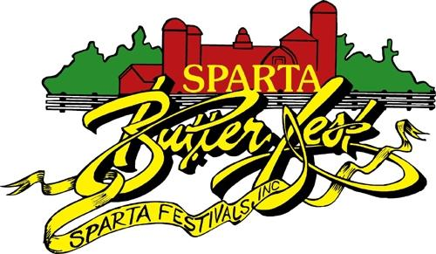
Sponsor Name: _______________________________________________
Contact Name: _______________________________________________
Phone: ______________ Email: _________________________________
Sponsorship Level
____ Parade Level $1000
Large banner with Business logo will be displayed on fest grounds.
Free float entry for Butterfest parade
Twelve Butterfest buttons
Acknowledgements during our Butterfest events
Business link on our website

____ Festmaster’s Level $500
Large banner with Business logo will be displayed on fest grounds.
Free float entry for Butterfest parade
Ten Butterfest buttons
Acknowledgements during our Butterfest events
Business link on our website

____ President Level $400
Large banner with Business logo will be displayed on fest grounds.
Free float entry for Butterfest parade
Eight Butterfest buttons
Acknowledgements during our Butterfest events
Business link on our website

____ Friend of Fest Level $300
Large banner with Business logo will be displayed on fest grounds.
Six Butterfest buttons
Acknowledgements during our Butterfest events
Business link on our website

____ Miss Sparta Level $200
Business logo on banner displayed on fest grounds.
Four Butterfest buttons
Business link on our website

____ Button Level $100
Business logo on banner displayed on fest grounds.
Two Butterfest buttons
Business link on our website

Please return to:
Sparta Festivals/Corporate Sponsorship
PO Box 89
Sparta, WI 54656

Deadline is May 15 for advertising purposes. If you have a logo or web link, please email butterfestcorpspon@gmail.com as soon as possible to get your information on our website

