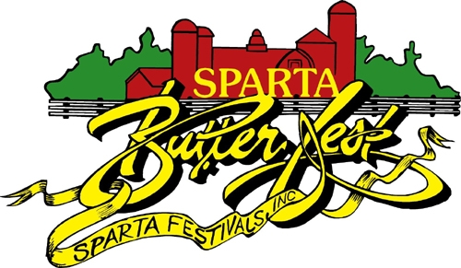
www.spartabutterfest.com
April 15, 2024

Dear Potential Parade Participant,

Once again it is time to plan our annual Sparta Butterfest Parade. This year marks 40 years of fun and family entertainment!

The parade is scheduled for Sunday, June 9, 2024, at 12:30 p.m. (rain or shine).

If you are a commercial entry, meaning you advertise any type of business the non-refundable fee for entering the parade is $50.00. This would include any racecar, semi truck, etc. Non-profit organization entries are free.

To be sure that you are part of this well-known parade, please register by May 24, 2024. Entering by this date allows us to develop a parade line-up and ensures that your number and other pertinent information will be forwarded to you 10-14 days prior to the parade. Entries received after the May 24, 2024 deadline will not be accepted, you are welcome to follow at the end of the parade route.

Please visit www.spartabutterfest.com for on-line registration. Under the forms tab you will see parade information and will need to select “click here to register on-line”.

We hope to see you at the 2024 Sparta Butterfest Parade. For a complete listing of event forms, please visit our website and remember to like us on Facebook.

Thank you for your support and consideration,

Sparta Festivals Inc.
Parade Committee
PO Box 89
Sparta, WI 54656

