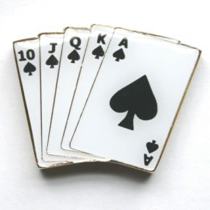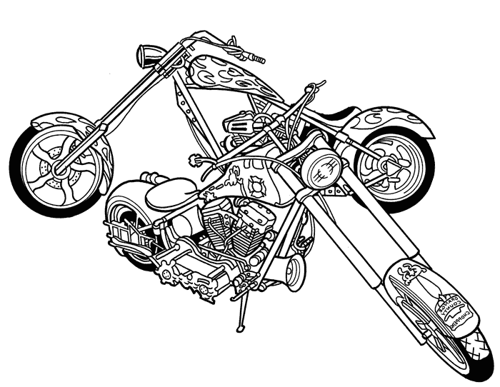Liability Waiver: Must Read and Sign
Sparta Butterfest Poker Run
June 7, 2014, Sparta, WI

SPECIAL EVENT & LIABILITY RELEASE AGREEMENT PLEASE READ CAREFULLY BEFORE SIGNING

I expressly consent to participation in this special event, Sparta Festival’s “4th Annual Sparta Butterfest Poker Run”, Sparta, WI and understand that any and all recreational activities involve inherent and other risks of INJURY and DEATH.

In consideration for being permitted to participate in the EVENT, the event being The 4th Annual Sparta Butterfest Poker Run, I voluntarily agree to expressly assume all risks of injury or death that may result from participation in the EVENT, or any other activity at staging sites and final destination of the ride route provided and all sponsors or contributors for the EVENT, all employees, volunteer workers, agents, representatives, successors-in-interest, and assigns (collectively “Providers”) from all liability for injury, death, and property loss and damage that results from participation in EVENT, or is related to any other activity for the EVENT, including all liability which results from the NEGLIGENCE of PROVIDERS, or any other person or cause.

I further agree to defend and indemnify PROVIDERS for any loss or damage arising from claims or lawsuits for personal injury, death, and property loss and damage related to participation in the EVENT or any related activity of the EVENT.
I agree to drive safely at all times, to conduct myself in a responsible manner, to comply with all applicable safety and DOT laws, to carry insurance for my vehicle as required by The State law of Wisconsin as well as the rules and policies of the EVENT and any participating facilities.

I authorize any person connected with PROVIDERS or the EVENT to administer first aid to me, as they deem necessary.
I authorize medical and surgical care and transportation to a medical facility or hospital for treatment necessary for my well-being, at my expense.

I agree that any and all photographs, videos, motion pictures, movies, or television coverage of me taken or made at any time during, by, or in connection with the EVENT, or any reproduction, likeness, or resemblance of the same, in any and every form, style, size, or color, as well as my name, may in any manner be used, published, displayed, dealt in, and copyrighted by PROVIDERS and/or their successors and assigns, or by any other person or business entity authorized by PROVIDERS, without any restriction or limitation whatsoever, for the marketing and promotion of future events and PROVIDERS.

This agreement is binding upon my heirs, executors, administrators, and assigns. I acknowledge this agreement is governed by the applicable laws of the State of WI. If any provision of this agreement is held in whole or in part to be unenforceable for any reason, the remainder of that provision and of the entire agreement will be severable and remain in effect.

I HAVE READ, UNDERSTAND, AND VOLUNTARILY AGREE TO THIS AGREEMENT AND RELEASE OF LIABILITY.

Participant’s Signature:_________________________________________________ Date:_______________

Participant (psgr/rider) Signature: _________________________________________ Date:_______________

Parent/guardian: If participant is a minor, I verify that I am the parent of guardian of the minor, and I have authority to enter into this agreement on behalf of the participant.

Parent/guardian’s Signature:______________________________________________ Date:_________________

