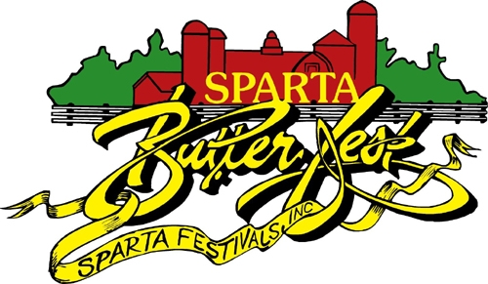
www.spartabutterfest.com
March 15, 2022

Dear Potential Parade Participant,

Once again it is time to plan our annual Sparta Butterfest Parade. This year marks 38 years of fun and family entertainment!

The parade is scheduled for Sunday, June 12, 2022, at 12:30 p.m. (rain or shine). Awards and cash prizes will be given out in different categories, along with the Festmaster and Lady Butterfest Awards for the best overall entry.

If you are a commercial entry, meaning you advertise any type of business the non-refundable fee for entering the parade is $50.00. This would include any racecar, semi truck, etc. Non-profit organization entries are free.

To be sure that you are part of this well-known parade, please register by May 27, 2022. Entering by this date allows us to develop a parade line-up and ensures that your number and other pertinent information will be forwarded to you 10-14 days prior to the parade. Entries received after the May 27, 2022 deadline will not be accepted, you are welcome to follow at the end of the parade route and you will not be announced or judged.

Please visit www.spartabutterfest.com for on-line registration. Under the forms tab you will see parade information and will need to select “click here to register on-line”.

We hope to see you at the 2022 Sparta Butterfest Parade. For a complete listing of event forms, please visit our website and remember to like us on Facebook.

Thank you for your support and consideration,

Sparta Festivals Inc.
Parade Committee
PO Box 89
Sparta, WI 54656

